Agenda Item : 2/01

= application site



Bentley Wood High School, Stanmore | P/3831/18

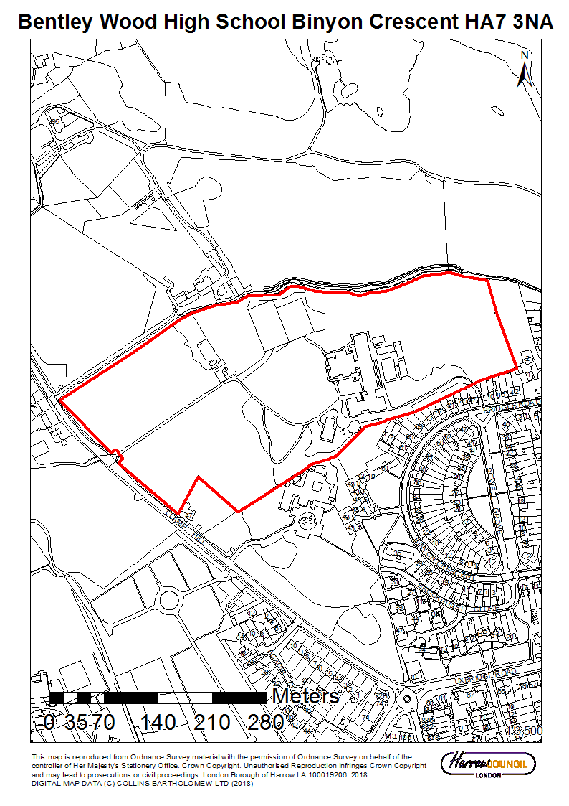

LONDON BOROUGH OF HARROW

PLANNING COMMITTEE

21st November 2018

APPLICATION NUMBER: | P/3831/18
VALIDATE DATE: | 17TH SEPTEMBER 2018
LOCATION: | BENTLEY WOOD HIGH SCHOOL, BINYON CRESCENT, STANMORE
WARD: | STANMORE PARK
POSTCODE: | HA7 3NA
APPLICANT: | BENTLEY WOOD HIGH SCHOOL
AGENT: | ARCADIS
CASE OFFICER: | NICOLA RANKIN
EXPIRY DATE: | 23RD OCTOBER 2018 (AGREED EXTENSION: 28TH NOVEMBER 2018)

PURPOSE OF REPORT/PROPOSAL

Single storey extension to North West elevation of kitchen/dining block including provision of extraction ducts to roof; hardsurfacing and external alterations

The Planning Committee is asked to:

RECOMMENDATION

- agree the reasons for approval as set out in this report, and

- grant planning permission subject to the Conditions listed in Appendix 1 of this report.

REASON FOR THE RECOMMENDATIONS

The proposed development would constitute inappropriate development in the Green Belt which would result in some limited harm to the character, appearance and openness of the Green Belt. However, the applicant has submitted a case for ‘Very Special Circumstances’ to justify the development. The proposed development would offer an improvement to meet the existing and future demands of the school and offer social benefits in terms of welfare and health. Accordingly, officers consider that the ‘Very Special Circumstances’ put forward together with the ‘great weight’ that the NPPF requires to be given to the need to expand and alter school are sufficient to outweigh the limited harm to the Green Belt in this case. Subject to conditions the proposed development would not result in any unacceptable ecological harm on the site and surrounding area. The proposed extension is considered to be a sympathetic addition which would respect the scale, design and appearance of the existing building and would provide a good environment for its intended users. No detrimental impacts would arise in respect of highways or residential amenity.

INFORMATION

This application is reported to Planning Committee as the proposed development exceeds 100m² of non-residential floorspace on a building/land where an interest is held by the Council and therefore falls outside Schedule 1(h) of the Scheme of Delegation.

Statutory Return Type: | E18 Minor Development
Council Interest: | None
GLA Community Infrastructure Levy (CIL) Contribution (provisional): | N/A. Does not apply to education facilities
Local CIL requirement: | N/A Does not apply to education facilities

HUMAN RIGHTS ACT

The provisions of the Human Rights Act 1998 have been taken into account in the processing of the application and the preparation of this report.

EQUALITIES

In determining this planning application the Council has regard to its equalities obligations including its obligations under section 149 of the Equality Act 2010.

For the purposes of this application there are no adverse equalities issues.

S17 Crime & Disorder Act

Policies 7.3.B and 7.13.B of The London Plan and Policy DM1 of the Development Management Polices Local Plan require all new developments to have regard to safety and the measures to reduce crime in the design of development proposal. It is considered that the development does not adversely affect crime risk.

LOCAL GOVERNMENT (ACCESS TO INFORMATION) ACT 1985
BACKGROUND PAPERS USED IN PREPARING THIS REPORT:

- Planning Application
- Statutory Register of Planning Decisions
- Correspondence with Adjoining Occupiers
- Correspondence with Statutory Bodies
- Correspondence with other Council Departments
- Nation Planning Policy Framework
- London Plan
- Local Plan - Core Strategy, Development Management Policies, SPGs
- Other relevant guidance

LIST OF ENCLOSURES / APPENDICES:

Officer Report:
Part 1: Planning Application Fact Sheet
Part 2: Officer Assessment
Appendix 1 – Conditions and Informatives
Appendix 2 – Site Plan
Appendix 3 – Floor Plans and Elevations

OFFICER REPORT

PART 1: Planning Application Fact Sheet

The Site

Address | Bentley Wood High School, Binyon Crescent, Stanmore, HA7 3NA
Applicant | Bentley Wood High School
Ward | Stanmore Park
Local Plan allocation | N/A
Conservation Area | No
Listed Building | N/A
Setting of Listed Building | N/A
Building of Local Interest | N/A
Tree Preservation Order | Yes
Other | Green Belt  Area of special character  Site of Nature Conservation Importance

Education
No. of Pupils | Existing
No. of Pupils | Proposed | No change proposed
No. of Forms of Entry | Existing
No. of Forms of Entry | Proposed | No change proposed
No. of Staff | Existing
No. of Staff | Proposed | No change proposed
No. of Classrooms | Existing
No. of Classrooms | Proposed | N/A
Outdoor space (m2) | Existing
Outdoor space (m2) | Proposed | No change proposed

PART 2: Assessment

- SITE DESCRIPTION

  - The application relates to Bentley Wood High School which is sited within the Green Belt, north of Uxbridge Road, Stanmore.

  - The application site relates to the kitchen/dining block which is located to the south west of the core set of buildings.

  - Access to the site for both vehicles and pedestrians is gained at the junction of Binyon Crescent and Sitwell Grove. The entrance drive runs along the south of the site towards the main school building. There is a further vehicle access point located to the south west along Clamp Hill.

  - The main school car park is situated to the south west and provides 65 car parking spaces including two disabled spaces. The car park is used by school staff only.

  - The main school building is three storey brick built structure which has two wings extending westwards at the northern and southern ends of the structure. It also features a part three / part four storey extension to the north wing of the school, which was granted under P/3803/07.

  - There are currently five buildings providing temporary classroom units sited on a hardsurfaced play area on the eastern side of the main building.

  - There are five tennis courts to the north west of the school buildings which are enclosed on all sides by mature trees. To the south west of the tennis courts there is an informal parking area with unmarked spaces. Further west are the school playing fields which are divided in two by a vehicle access road from Clamp Hill.

  - There are a number of mature trees across the site, with extensive coverage on the northern and western sides of the site adjacent to the existing buildings.

  - The entire school site falls within an Area of Special Character and a large part of the school grounds is within the Harrow Weald Park and the Hermitage Site of Borough Importance Grade 2 as identified on the Harrow Local Area Map (2013).

  - Residential properties of Binyon Crescent and Bridges Road are sited south of the application site.

  - The area surrounding the tennis courts is dominated by mature trees and vegetation. The site is currently enclosed by a chain link fence.

- PROPOSAL

  - The application proposes a single storey extension together with external alterations to the kitchen/dining block, located on the North West elevation in order to increase the capacity of the facility.

  - The extension of the existing building will encompass a further 138 sqm of kitchen and dining room space.

  - The proposed extension would extend the full width of the existing North West elevation (28.4m) with a depth of 5 metres.

  - A hard surfaced pathway would be constructed adjacent to the extension.

  - The proposed extension would have a flat roof to a height of 3 metres which would match the height of the existing building.

  - The proposed extension would be constructed in brick and white aluminium windows.

  - The windows on the other elevations would be upgraded to white aluminium windows.

  - Two galvanised steel kitchen extractor ducts would the installed on the roof to a height of 0.5 metres above the roof level.

  - The proposal would allow would allow for an increase in the capacity of the facility as well as a new food preparation area for the kitchen.

- RELEVANT PLANNING HISTORY

  - A summary of the relevant planning application history is set out in the table below

HAR/5162/E Erection of 2 storey extension
Granted 1 Jan 1960

HAR/5162/F Extension to form private chapel
Granted 29-Aug 1960

LBH/987/5 Outline: Erection of 2 storey extension to existing building to provide additional facilities
Granted 13th January 1977

P/707/05/CFU Single storey extension to art classroom, with adjacent timber decked area.
Granted 16 –May -2005
P/1002/06 – Replacement temporary double mobile classroom unit and temporary triple classroom unit (2 years)
Granted – 04-JUL-2006

P/1510/07 – single-storey double classroom teaching unit for temporary two year period
Granted – 26-JUL-2007

P/3887/07 – one single-storey and one two-storey portacabin to provide temporary classrooms and one two-storey portacabin building to provide a temporary science block
Granted – 17-JAN-2008

P/2737/08 – Retention of 3 temporary mobile classrooms (2 years)
Granted – 16-OCT-2008

P/2157/09 – Single-storey temporary building to provide 3 classrooms (3 years)
Granted – 06-NOV-2009

P/0281/10 – Details pursuant to conditions attached to planning permission P/2157/09 dated 06-NOV-2009
Approved – 06-MAY-2010

P/0855/10 – Single-storey temporary building to provide two additional classrooms (3 years); new walkway link to existing walkway; retention of temporary single storey double classroom unit (3 years)
Granted – 15-JUL-2010

P/0924/10 – Retention of three air conditioning units to temporary classroom building
Granted – 09-JUL-2010

P/2828/12 – Variation of condition 2 of planning permission P/0855/10 dated 15-JUL-2010 to allow the retention for an additional three years of a single storey temporary building to provide two additional classrooms and a temporary single storey double classroom unit.
Granted – 17–DEC-2012

P/2823/12 - variation of condition 2 of planning permission P/2157/09 dated 06-NOV-2009 to allow the retention for an additional three years of a single-storey temporary building to provide 3 classrooms.
Granted 17th December 2012

P/1719/14 Construction of a two storey linked extension to the south east of the existing building; construction of single storey extension with associated canopy to east elevation and single storey extension to west elevation of existing building; single storey infill extension to east; provision of kitchen extract duct over existing flat roof; provision of additional parking spaces and alteration to parking layout; hard and soft landscaping involving alteration to hard and soft play spaces; external alterations; involving removal of two existing mobile buildings (in association with the expansion of the existing 3 form entry primary school to a 4 form entry primary school).
Expiry: 16 – JUL – 2014

P/0237/16 Variation to the wording of Condition 23 (Mobile Classrooms) attached to planning permission P/1322/14 dated 14/10/14 to allow the mobile classroom to be retained for up to three years from 02/06/2016.
Granted 02-Jun -2016

- CONSULTATION

  - A total of 86 consultation letters were sent to neighbouring properties regarding this application.

4.5 The overall public consultation period expired on14th September 2018.

4.6 Adjoining Properties

Number of letters Sent | 86
Number of Responses Received | 0
Number in Support | 0
Number of Objections | 0
Number of other Representations (neither objecting or supporting) | 0

4.7 Statutory and Non Statutory Consultation

4.8 The following consultations have been undertaken:

4.9 External Consultation

4.10 A summary of the consultation responses received along with the Officer comments are set below:

Biodiversity Officer: No objection, subject to conditions

Arboricultural Officer: No objection, subject to conditions.

Environmental Health: No comment received

Drainage Authority: Please note that all internal manholes (proposed) should be moved out of the building especially in the kitchen and dining area, the applicant should liaise with Thames Water regarding this.

- POLICIES

  - Section 38(6) of the Planning and Compulsory Purchase Act 2004 requires that:

  - ‘If regard is to be had to the Development Plan for the purpose of any determination to be made under the Planning Acts, the determination must be made in accordance with the Plan unless material considerations indicate otherwise.’

  - The National Planning Policy Framework (NPPF) sets out the Government’s planning policies for England and how these should be applied; it is a material consideration in the determination of this application. The current NPPF was published in July 2018 and replaces the first NPPF (March 2012).

  - In this instance, the Development Plan comprises the London Plan (2016) and the Local Plan. The Local Plan comprises the Harrow Core Strategy (2012), Harrow and Wealdstone Area Action Plan (AAP) 2013, the Development Management Policies Local Plan (2013), the Site Allocations Local Plan (2013) and the accompanying policies map.

  - While this application has been principally considered against the adopted London Plan (2016) policies, some regard has also been given to relevant policies in the Draft London Plan (2017), as this will eventually replace the current London Plan (2016) when adopted and forms part of the development plan for the Borough.

  - The document was published in draft form in December 2017. Given that the draft Plan is still at early stages of the formal process it holds very limited weight in the determination of planning applications. Although this weight will increase as the Draft London Plan progresses to examination in public stage and beyond, applications would continue to be determined in accordance with the 2016 London Plan. It is anticipated that the Examination in Public will commence early 2019.

  - Notwithstanding the above, the Draft London Plan (2017) remains a material planning consideration, with relevant polices referenced within the report below and a summary within Informative 1.

6.0 ASSESSMENT

The main issues are:

- Principle of the Development
- Character and Appearance
- Residential Amenity
- Accessibility
- Trees and Biodiversity
- Drainage

  - Principle of Development

    - Bentley Wood high school lies within Green Belt land. As such, paragraphs 143 to 145 concerning proposals affecting the Green Belt are also relevant to this proposal. Paragraph 145 states that: “A local planning authority should regard the construction of new buildings as inappropriate development in the Green Belt”. It goes on to outline seven exceptions to this including:

“(c) the extension or alteration of a building provided that it does not result in disproportionate additions over and above the size of the original buildings”.

“(g) limited infilling or the partial or complete redevelopment of previously developed land, whether redundant or in continuing use (excluding temporary buildings) which would: not have greater impacts on the openness of the Green Belt than this existing development”…

    - The London Plan (2016) policy 7.16 recommends that London’s Green Belt be given the strongest protection where the objective is to keep land free of built development, in order to maintain the open character of these areas. The policies in The London Plan are reinforced by the policies in the Harrow Core Strategy (Policy CS 1F) (2012) and Harrow Development Management Policies Local Plan (2013). The protection for London’s Green Belt is reiterated by policy G2 of the Draft London Plan 2017.

    - Local policy DM 16 of the Harrow Development Management Polices Local Plan set out that “The redevelopment or infilling of previously developed sites in the Green Belt and Metropolitan Open land will be supported where the proposal where the proposal would not have a greater impact on the openness of the Green belt and the Metropolitan Open Land, and the purposes of including land within it, than the existing development, having regard to :
A the height of existing buildings on site
B the proportion of the site that is already developed
C the footprint, distribution and character of existing buildings on the site and
D the relationship of the proposal with any development on the site that is to be retained.”

    - Policy DM 46 of the local plan relates to new Community Sport and Education Facilities. This promotes the refurbishment and re-use of premises for educational facilities. The retention of such facilities is supported within policy DM 47, stating that “proposals for the redevelopment of educational facilities that secure enhanced re-provision on site will be supported”. This is aligned with the NPPF (2018) which outlines at paragraph 94 that great weight should be given to the need to create, expand or alter schools through the preparation of plans and decisions on applications.

    - The proposal is for an extension to the existing kitchen/dining block’s north western elevation. The footprint of the extension would be limited when considered in the context of the overall school site. Having regard to the location of the development and the nature of the application site, it is considered that it would not conflict with the purposes of Green Belt land set out under paragraph 134 of the NPPF.

    - Following a review of the planning history of the site, it is not clear when the original kitchen/dining hall block was constructed and whether this was at the same time as the original school building. However, the applicants have outlined that it was built at the same as the original school block was built in 1956 and that photos from the school opening confirm the timings. It is noted that the kitchen/dining hall was previously extended by a single storey extension, granted under planning permission LBH/23410 (dated 16th May 1983). In addition, the school has been substantially extended over the years including some large additions in the recent past such as the part three/part four storey extension to the north wing (Planning ref: P/3803/07) and the three storey linked extension to the north east of the building (Planning Ref: P/1322/14). Taking account of the additions to the original school building, it is considered that the proposed single storey side extension to the kitchen/dining block would give rise to a disproportionate addition over and above the size of the original school building. Furthermore, as a result of previous extensions to the school, the development cannot be considered to fall under exception (g) as it would not comprise a limited infill development on previously developed land and there would be a greater impact on the openness as a result of the additional bulk and mass of the proposal, albeit, it is acknowledged that this impact would be limited within the surrounding context. The development would therefore constitute inappropriate development in the Green Belt which would be harmful to the character and openness of the Green Belt.

    - As stated under paragraph 144 of the NPPF “When considering any planning application, local planning authorities should ensure that substantial weight is given to any harm to the Green Belt. ‘Very Special Circumstances’ will not exist unless the potential harm to the Green Belt, by reason of inappropriateness, and any other harm, is clearly outweighed by other considerations”. In view of the above, the applicant has put forward a case for ‘Very Special Circumstances’ to justify the proposed development.

    - The applicant has put forward the following points for consideration:

- Significant growth in student numbers at Bentley Wood from 2007 to 2018 by 482 students (68%)
- Dining hall undersized – currently 45% below DfE recommended size
- Kitchen area undersized – currently 27% below DfE recommended size
- Dining hall and kitchen are not able to cope on many occasions with the volume of students accessing the facility.
- On average only 37% of students eligible for free school meals has a lunch each day, the reasons cited for not having lunch are long queues and no space to eat once they have a meal
- Vulnerable students not having a hot lunch each day, 40% of students are eligible for pupil premium at Bentley Wood.

    - The current capacity in the school dining area is 134 students which the applicant outline is not sufficient for the numbers of students in the school. The lack of capacity together with the undersized kitchen space in turn has a significant impact on students who are eligible for a free school meal receiving this.

    - It is acknowledged that in recent years, the school student numbers have grown significantly with the introduction of the sixth form block in 2008 and an additional year seven group in September 2010. The school was expanded in 2015 (Planning permission ref: P/1322/14) after securing funding from the Department for Education’s Targeted Basic need Programme, designed to address the shortfall of school places within the London borough of Harrow which placed additional pressure on the kitchen hall and dining facility. In the academic year 2018/19 the school will accommodate 1212 students in a dining hall which can only seat 134 students at any one time.

    - The supporting documents outline that the existing canteen and dining facilities are currently non-compliant with the minimum

    - Usage figures supplied by the schools contracted catering provider evidence that on average only 61% of students who are eligible for a free school meal have food at either break or lunchtime. Of the 61% on average only 37% of Bentley Wood students who are eligible to receive a free school meal have a hot lunch each day in the school dining hall.

    - The school has outlined that catering for the existing students is a huge challenge with the canteen serving on average 600 students per day. However, a considerable proportion of the service occurs at lunchtime which total 55 minutes of the school day (45 minutes on Wednesday). It is outlined that lack of capacity for seating and long queues impacts on teaching time with students returning late as they did not have time to eat their lunch.

    - Currently the existing dining hall can seat 134 students which equates to only 60% of a year group at anyone time. This means that currently 40% of students cannot be accommodated in the same sitting if all students wanted a school meal in a year group. The current capacity of the dining area is only 11% of the school at any one time. Additionally, a high proportion of students are only accessing snack food due to the limited seating available. The proposed development would enable a total of 218 pupils to be seated at anyone time. Consequently the efficiency of the school lunchtime being significantly improved and the proposals would enable more eligible pupils to access a free school meal.

    - In officers opinion, ‘Very Special Circumstances’ need to be considered in the context of the level of potential harm/ inappropriateness (i.e. if only limited harm is being done to the openness, then the VSC to justify this are lower. It has already been acknowledged that the development would result in some harm to the openness of the Green Belt. However, in this instance the additional footprint would only be 145.5m² which is considered not to be significant within the context of the overall school site. Moreover, there would be very limited visibility of the proposal from within the school site due to its single storey height which would be mostly obscured by the existing buildings massing. Whilst the school has expanded its classroom space to meet additional educational need in the borough, the welfare provision has not been increased concurrently. Based on the evidence and information provided from the school, officers consider that the existing kitchen/dining facility is not fit for purpose and the proposal would offer an improvement to meet the existing and future demands of the school and offer social benefits in terms of welfare and health. Accordingly, officers consider that the ‘Very Special Circumstances’ put forward together with the ‘great weight’ that the NPPF requires to be given to the need to expand and alter school are sufficient to outweigh the limited harm to the Green Belt in this case. On this basis, the proposed development is considered to be acceptable in principle.

  - Character and Appearance

    - As outlined in paragraphs 124 to 131 of the NPPF (2018), The Government attaches great importance to the design of the built environment. Good design is a key aspect of sustainable development, is indivisible from good planning, and should contribute positively to making places better for people. It is important to plan positively for the achievement of high quality and inclusive design for all development, including individual buildings, public and private spaces and wider area development schemes.

    - Policy 7.4 (B) of the London Plan requires that buildings, streets and open spaces should provide a high quality design response that has regard to the pattern and grain of the existing spaces and streets in orientation, scale, proportion and mass. Policy 7.6 of the London Plan (2016) outlines that architecture should make a positive contribution to a coherent public realm, streetscape and wider cityscape. It should incorporate the widest quality materials and design it appropriate to its context. Buildings should have complimentary building materials, be of a proportion, composition, scale and orientation which enhances and defines the public realm.

    - The above design considerations are echoed in Draft London Plan (2017) Policy D1.

    - Officers consider that the proposed scale and massing of the extension would be acceptable, given this is already established by the existing building. The design of the building would reflect the existing character and built form of the surrounding buildings. There is no objection to the revised fenestration detailing which would help modernise and improve the current tired appearance of the building and provide good levels of light and views out from the dining room.

    - The proposed extension would use materials which would reflect and complement the existing building. The side elevations will comprise of a mix terracotta air bricks in a stretcher bond pattern to match the existing brick work, curtain walling, with a white PVCU fascia board above. The roof will match that of the existing building consisting of flat board insulation.

    - Subject to a condition to ensure that the proposed development would be carried out in accordance with the material details shown on the submitted drawings and documents, the development would comply with the development plans requirements outlined above.

  - Residential Amenity

    - The NPPF requires sustainable development, and as part of this developments should aim to minimise adverse effects on the local environment, which includes neighbouring properties.

    - Policy 7.6B, subsection D, of The London Plan (2016) states that new buildings and structures should not cause unacceptable harm to the amenity of surrounding land and buildings, particularly residential buildings, in relation to privacy, overshadowing, wind and microclimate. More detailed amenity considerations are set out under policy DM 1 of the local plan.

    - The closest neighbouring residential properties are located to the south of the application site in Binyon Crescent, some 70 metres away and at the Woodland Hill Nursing Home which is approximately 45 metres away. The school and neighbouring development is segregated by a dense group of mature trees. Having regard to the separation distances, presence of screening and the modest increase and scale and mass compared to the existing building, it is considered that the proposed would not give rise to any adverse amenity impacts with regard to loss of light, overshadowing, loss of privacy or outlook.

    - The application seeks to install an additional extractor fan system for the kitchen. The application is accompanied by an extraction and ventilation assessment together with manufacturer’s specification for the proposed equipment. The proposed extract fan would have a sound level of 70dBA which is equivalent to normal speech at approximately 1 to 2 metres and the supply fan would be much lower at 48dBA. The increase in scale of the kitchen facility is not likely to noticeably change the existing situation in terms of cooking odours. As such, it is considered that the development would not give rise to any amenity issues in this regard.

    - For these reasons, the proposal would satisfy the above policy requirements.

  - Accessibility

    - Local Plan Policy DM1 (Achieving a High Standard of Development) calls for all proposals to achieve a high standard of design and layout and sets out a range of relevant criteria, including (g) arrangements for safe, sustainable and inclusive access and movement to and within the site. Local Plan Policy DM2 (Achieving Lifetime Neighbourhoods) requires the location, design and layout of development, and any associated improvements to the public realm, transport and other infrastructure, to contribute to the creation of lifetime neighbourhoods. This policy is supported by guidance in the Access for All SPD.

    - The principal access to the site would remain as existing. A new delivery route is proposed to the kitchen to provide improved kitchen functionality. Two emergency escape routes are provided to the western elevation. The new routes replace the existing emergency doors that would be removed following the extension. The proposed development would improve access of the site and is considered to be acceptable in relation to the above policy requirements.

  - Trees and Biodiversity

    - Policies DM 20 and DM 21 seek to ensure the protection of biodiversity and access to nature. Policy DM 20 requires that “The design and layout of new development should retain and enhance any significant features of biodiversity value within the site. Potential impacts on biodiversity should be avoided or appropriate mitigation sought”. Policy DM 21 outlines that proposals should secure the restoration and recreation of significant components of the natural environment.

    - A large part of the school grounds is within the Harrow Weald Park and the Hermitage Site of Borough Importance Grade 2 as identified on the Harrow Local Area Map (2013). The application site is situated partially within the defined area and partly just outside.

    - The application is accompanied by an ecological survey. The studies make a number of recommendations to improve the ecological value of the site for a range of species. The details have been reviewed by the Council biodiversity officer who considers that some additional biodiversity enhancement should be secured to offset the impact of the development proposals. Should planning permission be granted, appropriate planning conditions can be secured to address these issues. At the time of writing this report, additional information is being sought on the nature of appropriate biodiversity enhancements and this will be reported via the committee addendum.

    - London Plan Policy 7.21 Trees and Woodland states that existing trees of value should be retained and that, wherever appropriate, additional trees should be planted in new development. Local Plan Policy DM22 Trees and Landscaping requires development proposals to include hard and soft landscaping and calls for retained trees to be protected during construction.

    - Bentley Wood High school is located within the Harrow Weald Ridge Area of Special Character, defined by policy DM 6 of the Development Management Policies Local Plan (2013). The Harrow Weald Ridge provides an elevated horizon of tree cover and open countryside which spans across the north of the Borough. Although there are dispersed developments across the Area of Special Character, the area as a whole tends to be viewed as a continuous wooded ridge. The trees on the Bentley Wood site make a significant contribution to the amenity and character of the Harrow Weald Ridge Area of Special character.

    - An Arboricultural report has been submitted with the application which concludes that all adjacent trees near the development can be retained subject to mitigation and protective measures including the erection of temporary protective fencing, ground protection, careful excavation of the service trenching and the use of pre-emptive root pruning as appropriate. The details have been referred to the Council’s Arboricultural officer who considers that the proposal is acceptable and the trees can be retained subject to securing conditions for their protection.

    - Subject to conditions in respect of the above matters, officers consider that the ecological and aesthetic value of the area would not be harmed and the development would thereby comply with policies 7.21 and 7.19 of The London plan (2016) and policies DM 20, 21 and 22 of the Harrow Development Management Policies Local Plan (2013).

  - Drainage

    - Core Strategy Policy CS1 U and local plan policy DM 10 undertakes to manage development to achieve an overall reduction in flood risk and increased resilience to flood events.

    - London Plan Policy 5.13 states that development should utilise sustainable urban drainage systems (SUDS) and should aim to achieve greenfield run-off rates. Policy 5.13 of the London Plan sets out a drainage hierarchy to manage surface water run-off as close to its source as possible.

    - The site is within Flood Zone 1, meaning that the site is assessed as having a less than 1 in 1,000 annual probability of fluvial flooding from main rivers. However, the Local Plan designated the site as part of a critical drainage area meaning that it is susceptible to flooding from surface water.

    - The application is accompanied by a drainage plan which has been referred to the local drainage authority who have raised no objected to the proposal. They have advised that all internal manholes (proposed) should be moved out of the building especially in the kitchen and dining area and that the applicant should liaise with Thames Water regarding this. An informative is attached in respect of this.

    - Accordingly, it is considered that the proposed development would be acceptable in relation to the above policies.

- CONCLUSION AND REASONS FOR APPROVAL

  - The proposed development would constitute inappropriate development in the Green Belt which would result in some limited harm to the character, appearance and openness of the Green Belt. However, the applicant has submitted a case for ‘Very Special Circumstances’ to justify the development. The proposal is therefore recommended for grant as it complies with the relevant policies of the development plan.

APPENDIX 1: Conditions and Informatives

Conditions

- Timing

The development hereby permitted shall be begun before the expiration of three years from the date of this permission.

REASON: To comply with the provisions of Section 91 of the Town and Country Planning Act 1990.

- Approved Drawing and Documents

Unless otherwise agreed in writing by the local planning authority, the development shall be carried out and completed in accordance with the following approved drawings and documents: A102 Rev B; A201 Rev A; A202 Rev B; A302; Compact SCP Product Brochure; Planning, Design and Access Statement (August 2018); M001; M002; Preliminary Ecological Appraisal by Elite Ecology ( August 2018); Supporting Document titled: Bifurcated Case Axial Fans (BIFA); Bentley Wood Dining Room Ventilation and Extraction (24th August 2018); A100; Arboricultural Impact Assessment by A.T. Coombes Associates (15 August 2018); Supporting Document titled: Bentley Wood High School Case for ‘Very Special Circumstances’.

REASON: For the avoidance of doubt and in the interests of proper planning.

- Materials

The development shall be carried out and completed in accordance with the details of the materials shown on submitted drawings and detailed in the supporting documents and retained as such thereafter.

REASON: To ensure that the development is carried out to the highest standards of architecture and materials in accordance with Policies 7.6 and 7.7 of the London Plan (2016) and Policy DM 1 of the Harrow Development Management Polices Local Plan (2013).

- Trees 1

Before any development work begins, a pre-commencement meeting shall take place between the appointed arboricultural consultant and site manager to discuss working procedures and ensure tree protection measures outlined in the submitted and approved details have been adhered to.

REASON: The existing trees represent an important amenity feature which the local planning authority considers should be protected, and as required by policy DM 22 of the Harrow Development Management Policies Local Plan (2013).

Trees 2

The Arboricultural Method Statement (Appendix 5 Method Statement)and Tree Protection Plan (Appendix 4 TPP) submitted in support of the application shall be adhered to in full, subject to the pre-arranged monitoring and supervision as outlined in Section 11 of the report

REASON: The existing trees represent an important amenity feature which the local planning authority considers should be protected, and as required by policy DM 22 of the Harrow Development Management Policies Local Plan (2013).

Trees 3

The development hereby permitted shall not be occupied until a completed schedule of site supervision and monitoring of tree protection measures has been submitted and approved in writing by the local planning authority. This condition may only be discharged on completion and subject to satisfactory evidence of compliance through supervision and monitoring of tree protection throughout construction.

REASON: in order to ensure compliance with tree protection measures as approved in accordance with policy DM 22 of the Harrow Development Management Policies Local Plan (2013).

Informatives

- Polices:

The following polices are relevant to this decision:

National Planning Policy
National Planning Policy Framework 2018

The London Plan [2016]:
3.16 – Protection and Enhancement of Social Infrastructure
3.18 – Education Facilities
5.3 – Sustainable design and construction
5.12 – Flood risk management
5.13 – Sustainable Drainage
6.3 – Assessing effects of development on transport capacity
6.9 – Cycling
6.13 – Parking
7.1 – Building London’s neighbourhoods and communities
7.2 – An inclusive environment
7.3 – Designing out crime
7.4 – Local character
7.6 – Architecture
7.16 – Green Belt
7.19 – Biodiversity and Access to Nature
7.21 – Trees and Woodlands

The Draft London Plan (2017)
Policy D1 London’s form and characteristics
Policy D2 Delivering good design
Policy D3 Inclusive design
Policy S3 Education and childcare facilities
Policy G2 Green Belt

The Harrow Core Strategy 2012
CS1 – Overarching Policy
CS7 – Stanmore & Harrow Weald

Development Management Policies Local Plan (2013)
DM1 Achieving a High Standard of Development
DM6 Areas of Special Character
DM9 Managing Flood Risk
DM10 On Site Water Management and Surface Water Attenuation
DM12 Sustainable Design and Layout
DM16 Maintaining the Openness of the Green Belt and Metropolitan Open Land
DM20 Protection of Biodiversity and Access to Nature
DM21 Enhancement of Biodiversity and Access to Nature
DM22 Trees and Landscaping
DM46 New Community, Sport and Education Facilities
DM47 Retention of existing education and community facilities.

- Manholes

The applicant is advised that that all internal manholes (proposed) should be moved out of the building especially in the kitchen and dining area and that the applicant should liaise with Thames Water regarding this. Thames Water Developer Servicers can be contacted on 0800 009 392.

- SUDS

Surface water run-off should be controlled as near to its source as possible through a sustainable drainage approach to surface water management (SUDS). SUDS are an approach to managing surface water run-off which seeks to mimic natural drainage systems and retain water on or near the site as opposed to traditional drainage approaches which involve piping water off site as quickly as possible.
SUDS involve a range of techniques including soakaways, infiltration trenches, permeable pavements, grassed swales, ponds and wetlands. SUDS offer significant advantages over conventional piped drainage systems in reducing flood risk by attenuating the rate and quantity of surface water run-off from a site, promoting groundwater recharge, and improving water quality and amenity. Where the intention is to use soakaways they should be shown to work through an appropriate assessment carried out under Building Research Establishment (BRE) Digest 365.
Support for the SUDS approach to managing surface water run-off is set out in the National Planning Policy Framework (NPPF) and its accompanying technical guidance, as well as the London Plan. Specifically, the NPPF (2012) gives priority to the use of sustainable drainage systems in the management of residual flood risk and the technical guidance confirms that the use of such systems is a policy aim in all flood zones. Policy 5.13 of the London Plan (2012) requires development to utilise sustainable drainage systems unless there are practical reasons for not doing so. Sustainable drainage systems cover the whole range of sustainable approaches to surface drainage management. They are designed to control surface water run-off close to where it falls and mimic natural drainage as closely as possible. Therefore, almost any development should be able to include a sustainable drainage scheme based on these principles.
The applicant can contact Harrow Drainage Section for further information.
Reason: To manage, reduce and mitigate the effects of flood risk following guidance in the National Planning Policy Framework.

- Considerate Contractor Code of Practice

The applicant's attention is drawn to the requirements in the attached Considerate Contractor Code of Practice, in the interests of minimising any adverse effects arising from building operations, and in particular the limitations on hours of working

- Compliance with Planning Conditions

Compliance With Planning Conditions Requiring Submission and Approval of Details Before Development Commences
  - You will be in breach of planning permission if you start development without complying with a condition requiring you to do something before you start. For example, that a scheme or details of the development must first be approved by the Local Planning Authority.
  - Carrying out works in breach of such a condition will not satisfy the requirement to commence the development within the time permitted.
  - Beginning development in breach of a planning condition will invalidate your planning permission.
  - If you require confirmation as to whether the works you have carried out are acceptable, then you should apply to the Local Planning Authority for a certificate of lawfulness.

- Pre Application Advice

Statement under Article 35(2) of The Town and Country Planning (Development Management Procedures) (England) Order 2015. This decision has been taken in accordance with paragraphs 187-189 of The National Planning Policy Framework. Pre-application advice was sought and provided and the submitted application was in accordance with that advice.

Plan Nos: A102 Rev B; A201 Rev A; A202 Rev B; A302; Compact SCP Product Brochure; Planning, Design and Access Statement (August 2018); M001; M002; Preliminary Ecological Appraisal by Elite Ecology ( August 2018); Supporting Document titled: Bifurcated Case Axial Fans (BIFA); Bentley Wood Dining Room Ventilation and Extraction (24th August 2018); A100; Arboricultural Impact Assessment by A.T. Coombes Associates (15 August 2018); Supporting Document titled: Bentley Wood High School Case for ‘Very Special Circumstances’.

Appendix 2: Site Plan

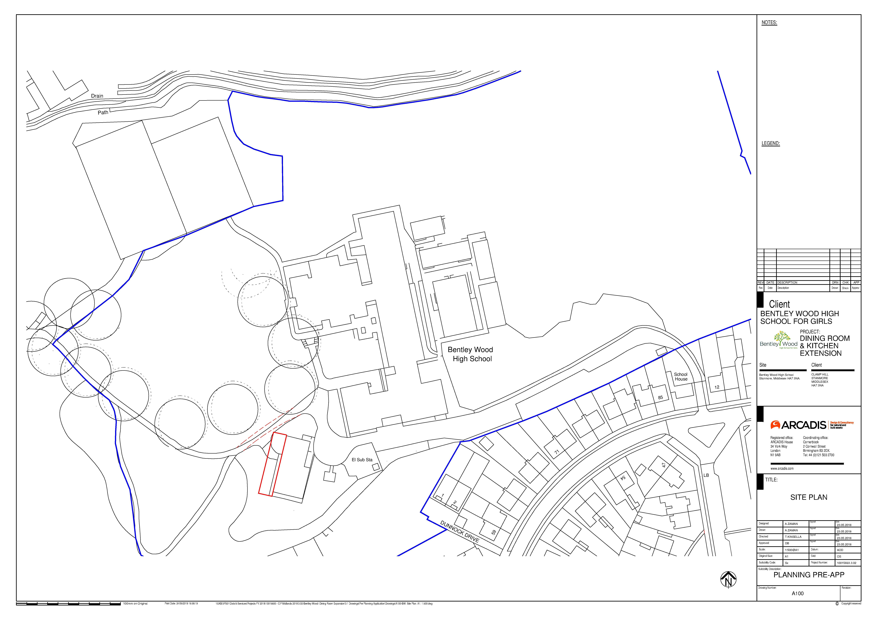

Appendix 3 – Floor Plans and Elevations

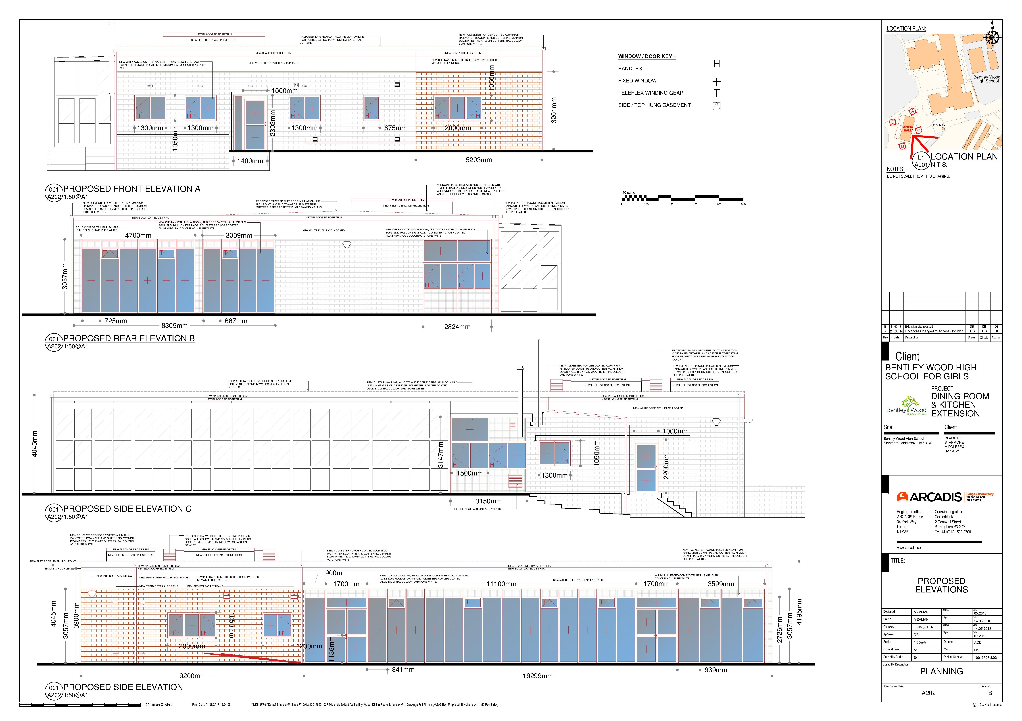

Proposed Elevations
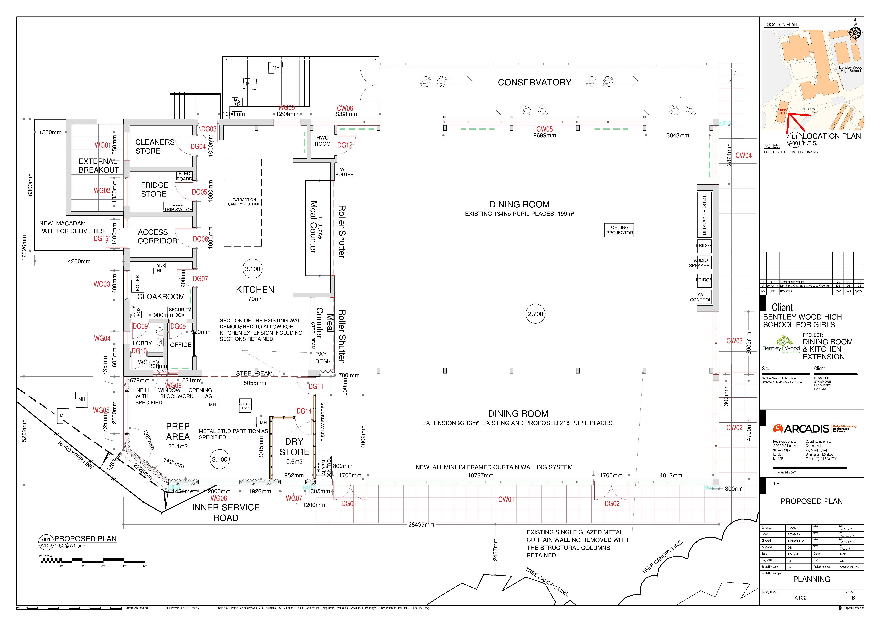
Proposed Floorplan

This page has been left intentionally blank

